Professional Dairy Producers® is a dairy producer-led organization founded by dairy farmers, led by dairy farmers and serving dairy farmers.
PDPW bylaws allow one vote per dairy farm membership. Since the PDPW Board of Directors has three available positions, each PDPW dairy producer member can vote for up to three individuals.

Cast your ballot in one of two manners: 1) at the 2024 PDPW Business Conference, March 13-14, in Wisconsin Dells, Wis., or 2) mail your marked ballot to PDPW, using the enclosed envelope. Mail-in ballots must be postmarked by Monday, February 19, 2024. All votes will be kept confidential and counted by the PDPW ballot clerks at the 2024 PDPW Business Conference. Ballots will also be available on-site at the Business Conference. All votes must be in by 1:00 p.m. on Thursday, March 14.

If you have questions about the process, candidates or your ballot, please call PDPW at 800-947-7379.

PDPW Board of Director candidates: Select three (3)

 | 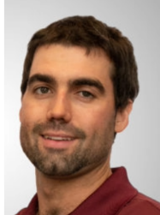 | Jake Hoewisch of Waupaca County, Wis., is the fifth generation to own and operate Hoewisch Homestead Dairy, LLC, with his wife, Jennifer, parents and uncle. They milk 150 registered Holstein A2/A2 cows twice daily, with a focus on milk quality and low somatic cell count. In 2018, they diversified with a meat to table beef business, H&S Tasty Acres LLC, owned in partnership with another family. They also have a custom manure drag line and baling business. Hoewisch is running for the PDPW board because he wants to be a strong voice in the dairy industry and believes PDPW is the best place for that.
 | 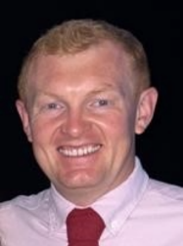 | Paul Lippert of Pittsville, Wis. owns Grass Ridge Farm, LLC, with his father, Matt, and brother, Carl. The dairy is home to 700 registered Holsteins and Jerseys as well as 600 young stock. Paul is the herdsman and human resources manager. He graduated from UW-River Falls with a Dairy Science degree. Grass Ridge Farm hosted the Pittsville FFA Dairy Breakfast in 2018. Paul believes strongly in PDPW’s educational focus, attending many events himself. He currently serves as president for the Wood Area Holstein Breeders and Chair of the Purple Ribbon Classic Sale.
 | 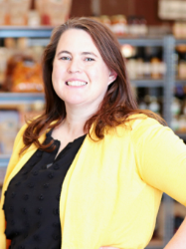 | Heather Moore of Maquoketa, Iowa, and her husband, Brandon, own and operate Moore Family Farms, a first-generation farm with 40 registered Holstein cows, 800-head beef feed yard, laying hen facility, and small goat herd. They are partners in Rockdale Locker and own Moore Local and Moore Family Farms Creamery, where they process their milk into cheese and have two retail locations. Moore is a 4-H leader and serves on the county Farm Bureau and Iowa Holstein boards. She is running for the PDPW board because she sees the positive impact that PDPW has on the dairy community and has continually been impressed with how the organization serves the industry.
 | 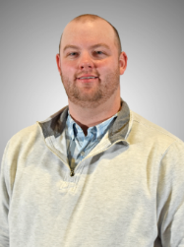 | Brady Weiland of Columbus, Wis., is the fifth generation to own and operate Weiland Dairy LLC, with his parents, brother, and eight employees. Brady and his brother also own and operate High Gear Holsteins LLC and employ an additional nine employees. As dairy manager, Brady oversees the two 600-cow herds. He graduated from Madison Area Technical College and furthered his education at the UW-Madison Farm and Industry Short Course. Brady believes strongly in PDPW’s educational focus, and regularly attends PDPW events. He is a member of the Wisconsin Beef Council, a volunteer firefighter, and has served as church treasurer and council member.

